1. 가설검정 (예제)

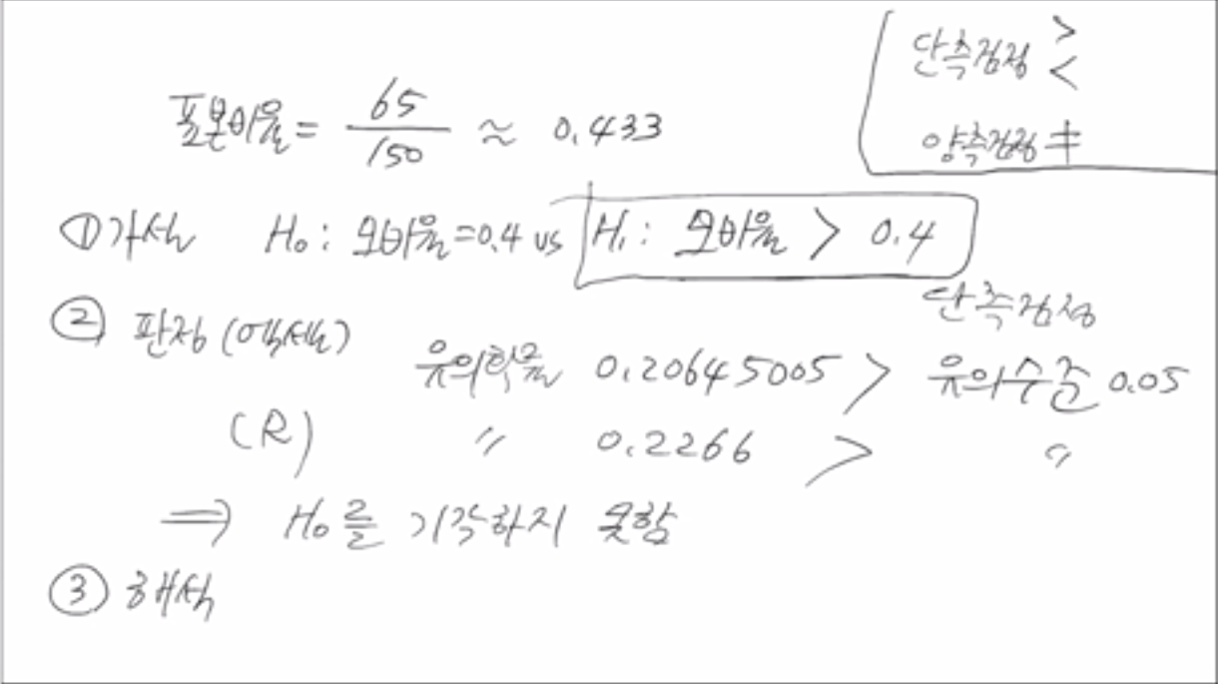

- 단측검정: >, < // 양측검정: 같지않다 (=x)

2. 예제 2

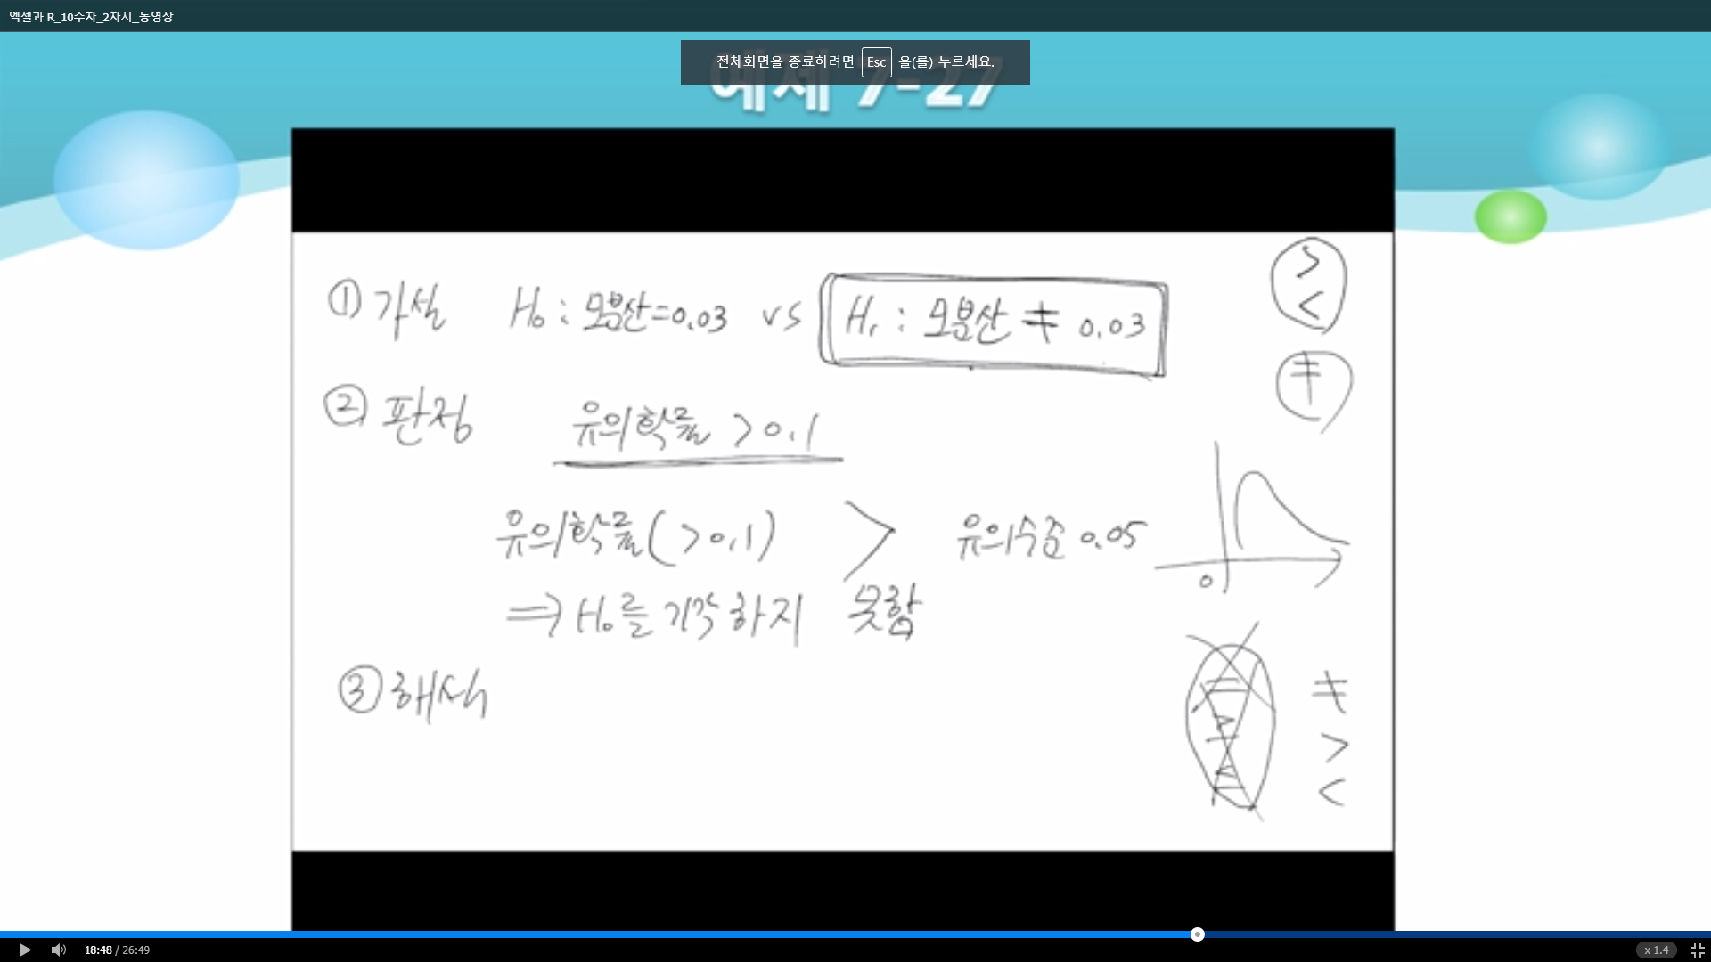

- 앞의 문제들과 같음

3. 예제 3

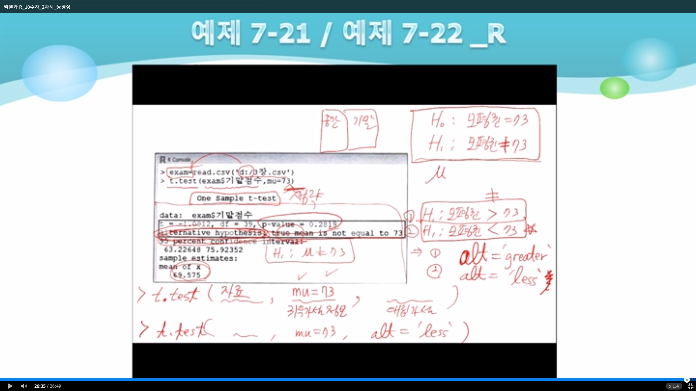

> exam=read.csv("102ch3.csv")

> t.test(exam$기말점수,mu=73)

One Sample t-test

data: exam$기말점수

t = -1.0912, df = 39, p-value = 0.2819

alternative hypothesis: true mean is not equal to 73

95 percent confidence interval:

63.22648 75.92352

sample estimates:

mean of x

69.575